**TASK: 1 DATE: 16-02-2024**

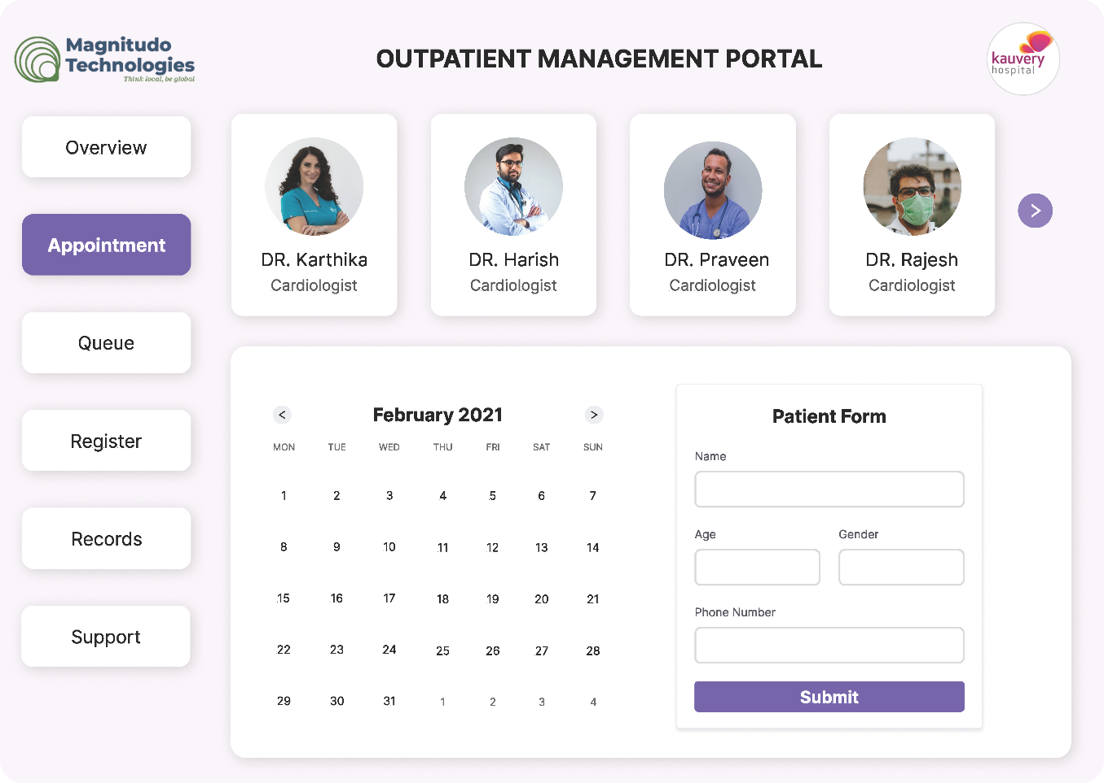**DASHBOARD - APPOINTMENT PAGE**

**DASHBOARD - REGISTER**

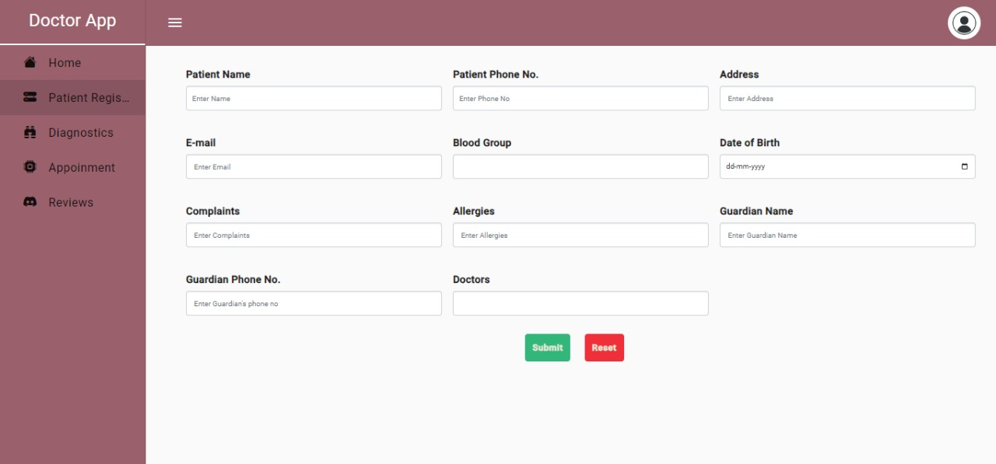

**DASHBOARD - DIAGNOSTICS REPORT**

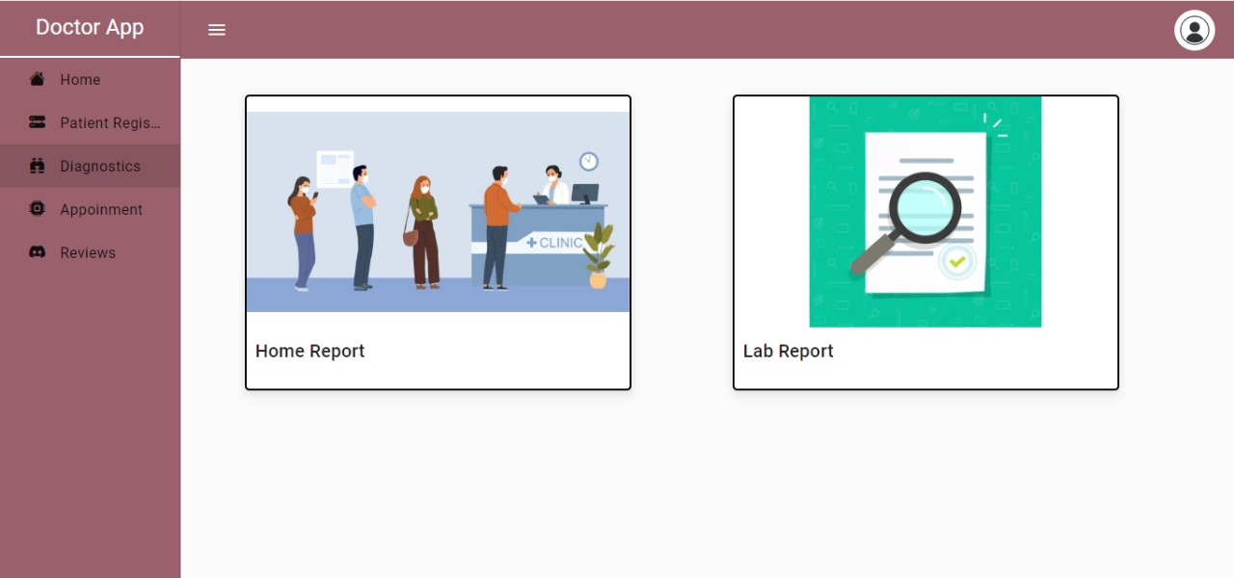

**DASHBOARD – DIAGNOSTICS REPORT: HOME REPORT**



**DASHBOARD – DIAGNOSTICS REPORT: LAB REPORT**

